E-Portfolio   
  
Python Fundamentals  
  
Exercise 1  
  
Code:   
# Basic Math Operations in Python

# ------------------------------------------

# i. Addition of two numbers

a = 15

b = 7

addition_result = a + b

print("Addition Result:", addition_result)

# ------------------------------------------

# ii. Subtraction of two numbers

a = 15

b = 7

subtraction_result = a - b

print("Subtraction Result:", subtraction_result)

# ------------------------------------------

# iii. Multiplication of two numbers

a = 15

b = 7

multiplication_result = a * b

print("Multiplication Result:", multiplication_result)

# ------------------------------------------

# iv. Division of two numbers

a = 15

b = 7

division_result = a / b

print("Division Result:", division_result)

# ------------------------------------------

# v. Remainder (Modulus) of two numbers

a = 15

b = 7

modulus_result = a % b

print("Modulus (Remainder) Result:", modulus_result)

# ------------------------------------------

# vi. Power (Exponentiation)

a = 2

b = 4

power_result = a ** b

print("Power Result:", power_result)

Result:  
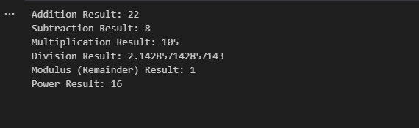  
  
  
  
Exercise 2   
  
Code:  
# Exercise 2: Python Data Types

# i. Create a list of 5 different fruits and print the list

fruits = ["Apple", "Banana", "Mango", "Grapes", "Orange"]

print("List of Fruits:", fruits)

# ii. Create a tuple of 3 different animals and print the tuple

animals = ("Tiger", "Elephant", "Kangaroo")

print("Tuple of Animals:", animals)

# iii. Create a dictionary of 3 programming languages and their release dates

languages = {

    "Python": 1991,

    "Java": 1995,

    "JavaScript": 1995

}

print("Programming Languages and Release Dates:", languages)

# iv. Create a set of 3 different colours and print the set

colours = {"Red", "Blue", "Green"}

print("Set of Colours:", colours)

# v. Create a string variable with a sentence

sentence = "Python is an easy-to-learn programming language."

print("Sentence:", sentence)

result: 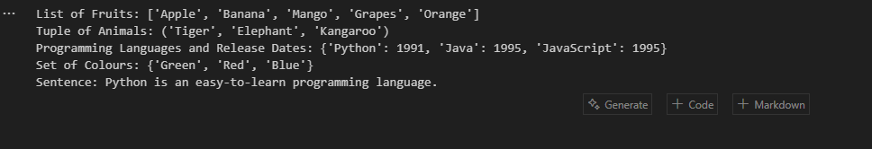

Exercise 3  
  
Code:  
  
Exercise 3: Conditions

# ------------------------------------------

# i. Check if a number is positive, negative, or zero

number = float(input("Enter a number: "))

if number > 0:

print("The number is positive.")

elif number < 0:

print("The number is negative.")

else:

print("The number is zero.")

# ------------------------------------------

# ii. Check if a string starts with a vowel or consonant

text = input("Enter a word: ")

if text:

first_char = text[0].lower()

if first_char in "aeiou":

print("The word starts with a vowel.")

elif first_char.isalpha():

print("The word starts with a consonant.")

else:

print("The word does not start with a letter.")

else:

print("Empty string entered.")

# ------------------------------------------

# iii. Check if two numbers are equal

num1 = float(input("Enter the first number: "))

num2 = float(input("Enter the second number: "))

if num1 == num2:

print("The numbers are equal.")

else:

print("The numbers are not equal.")  
  
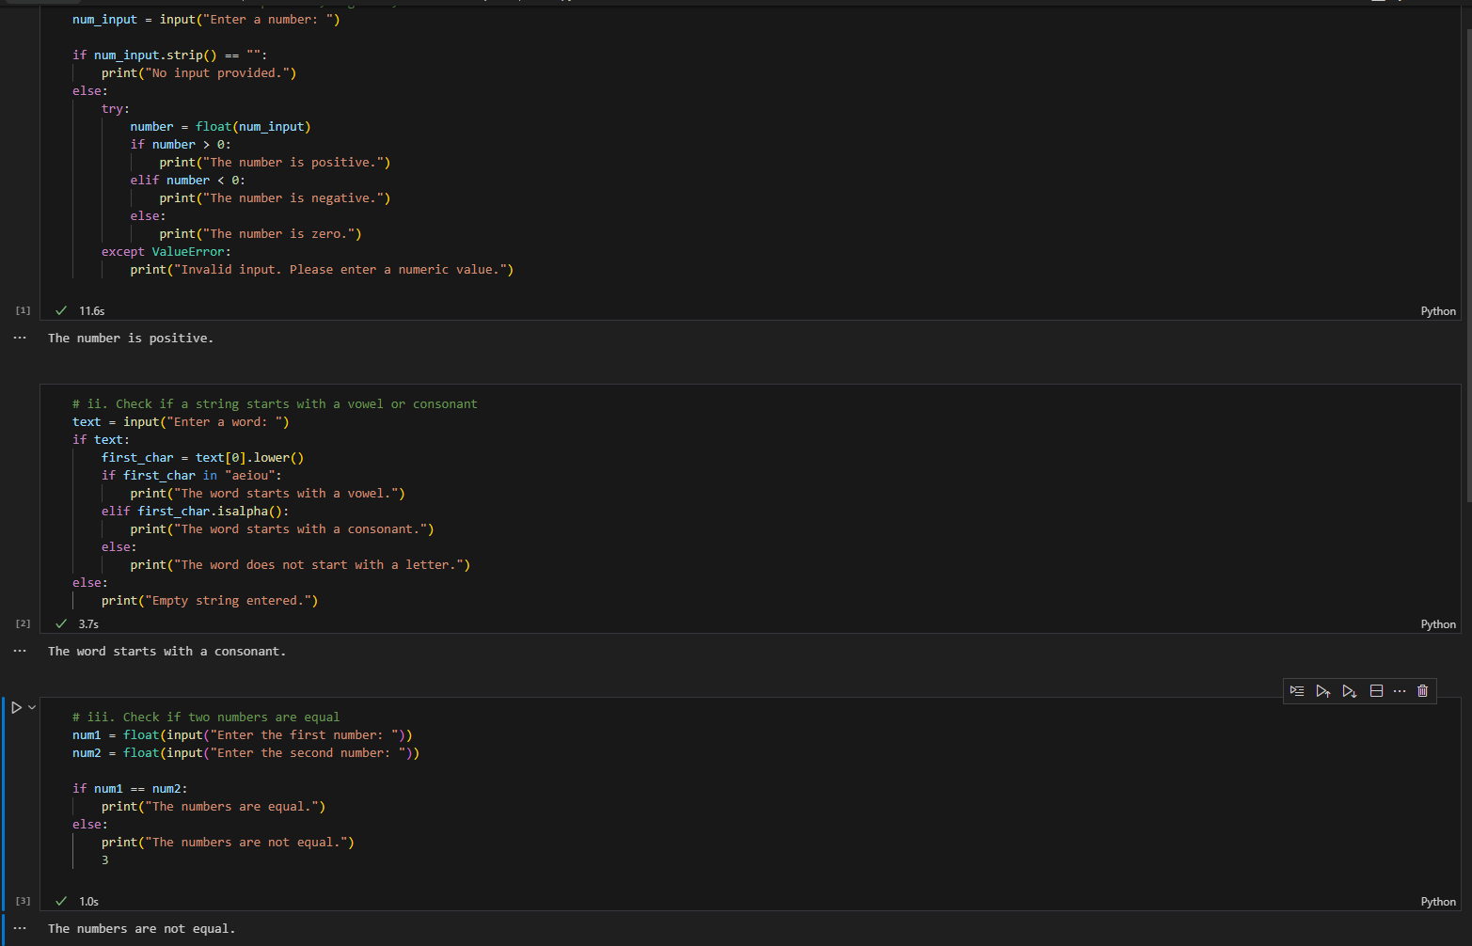

Exercise 4

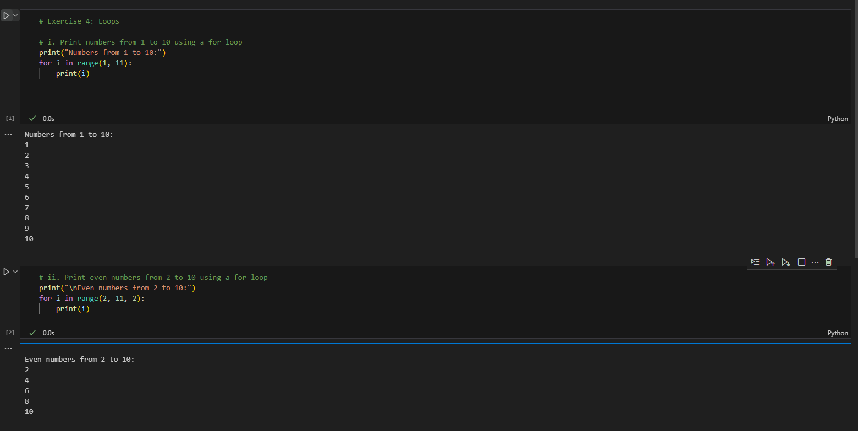

Exercise 5  
  
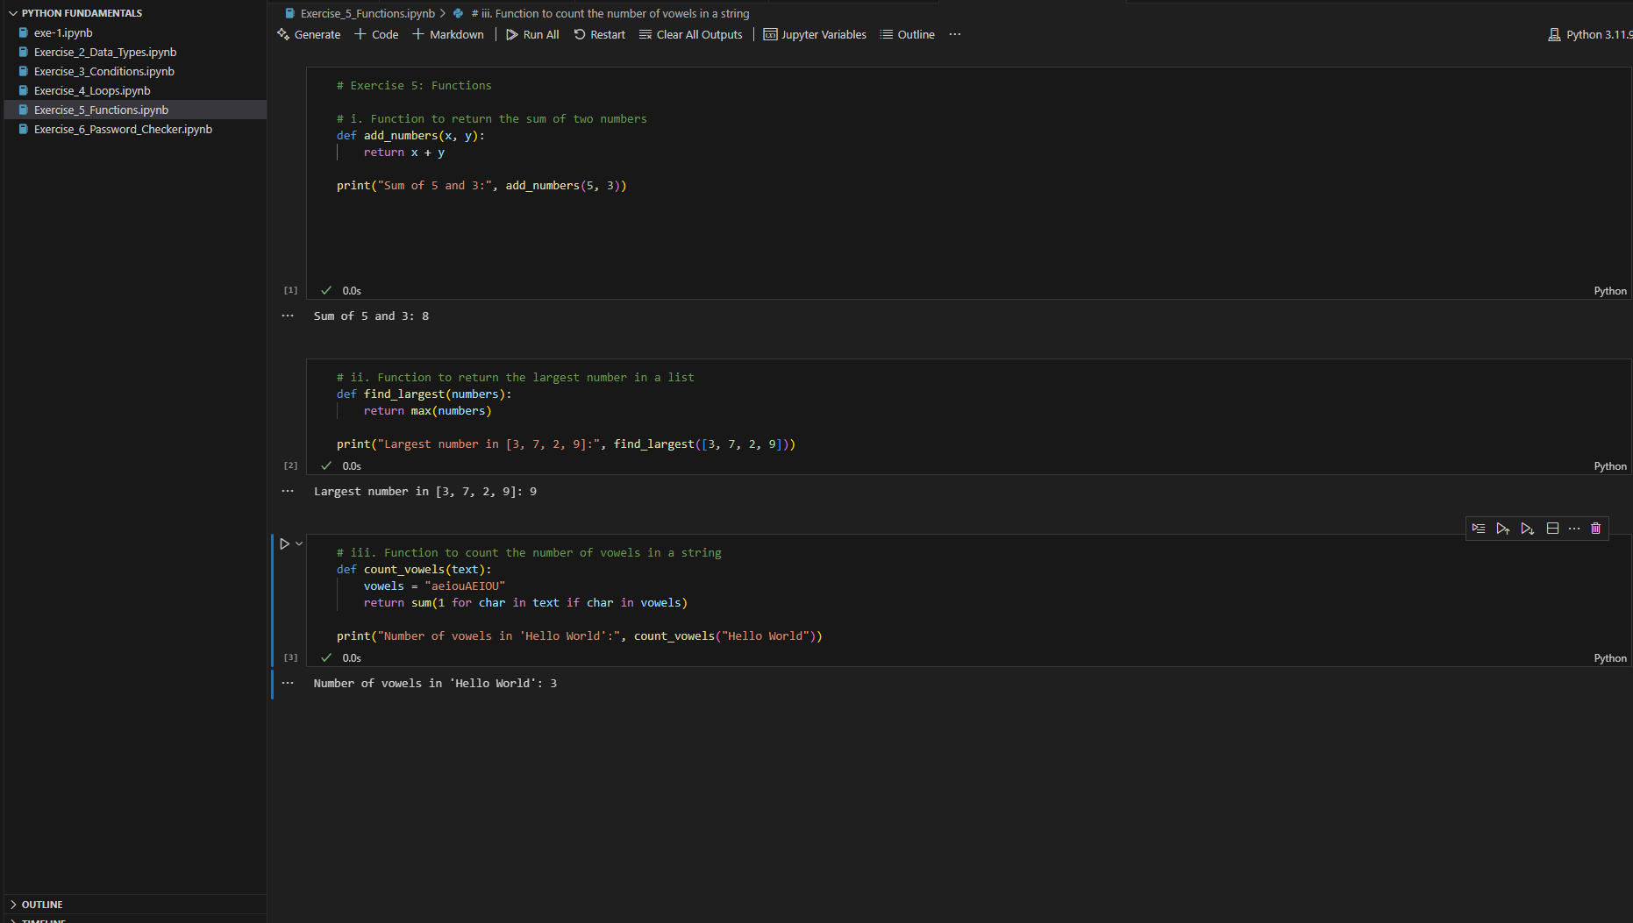  
  
  
Exercise 6

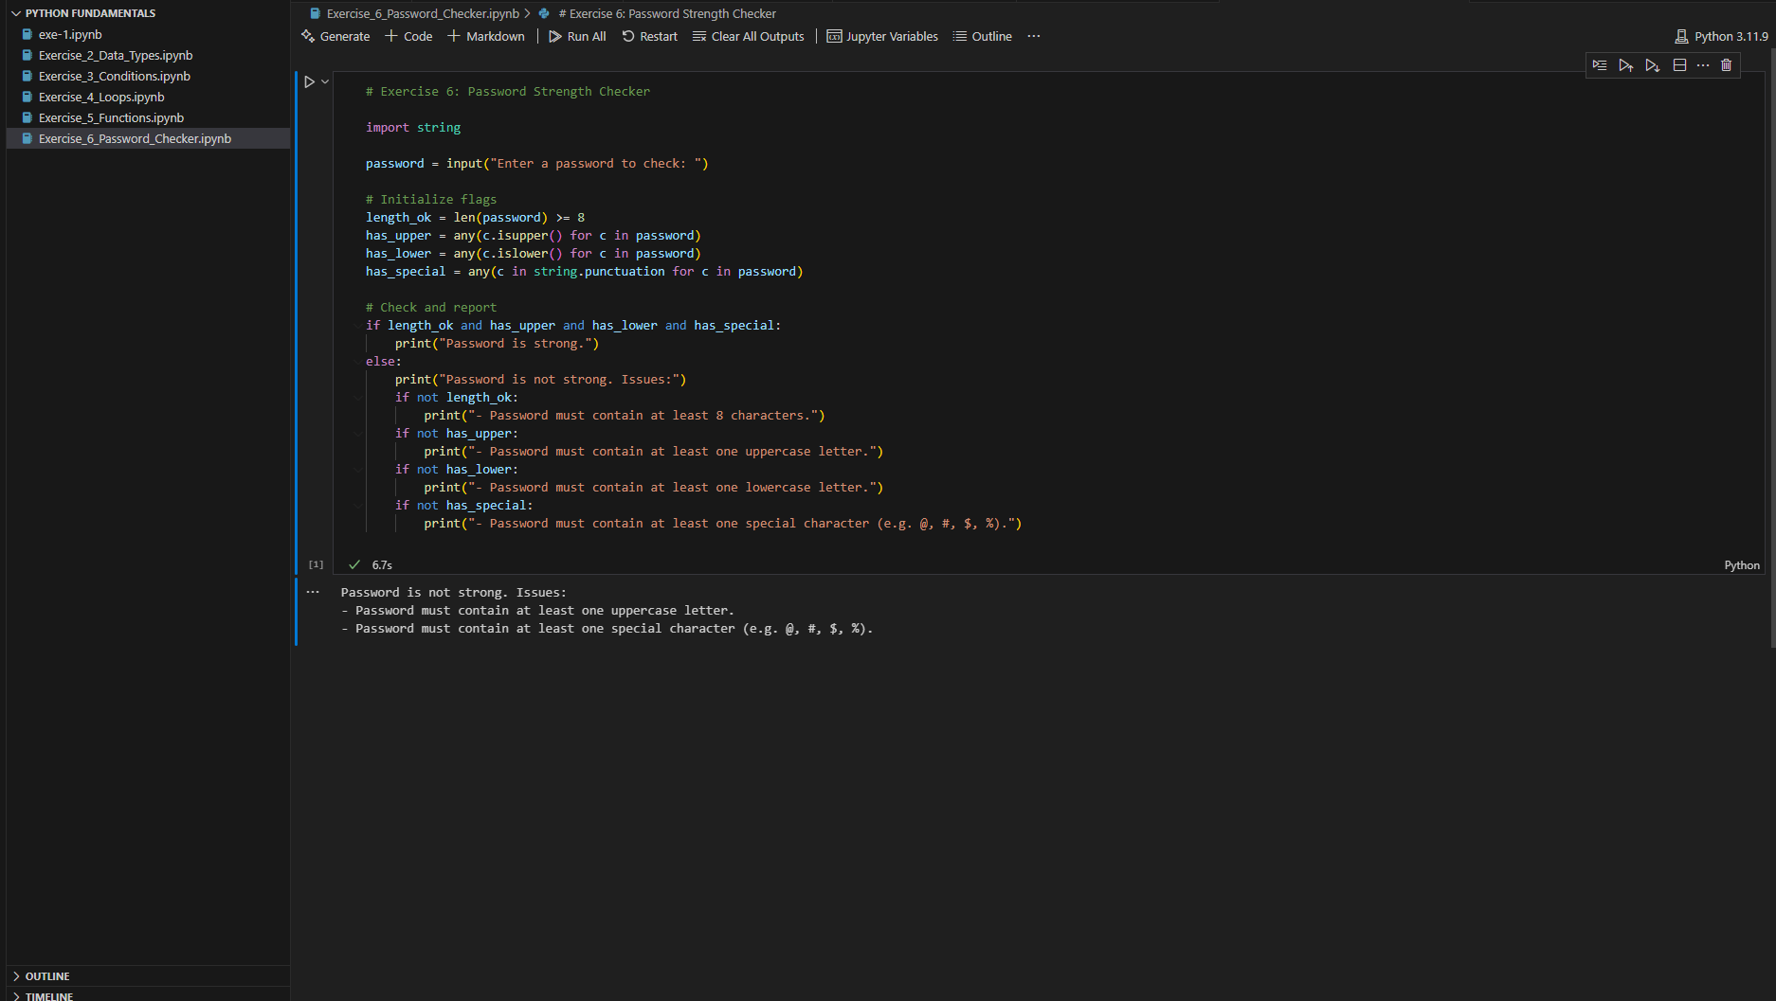  
  
Exercise 7   
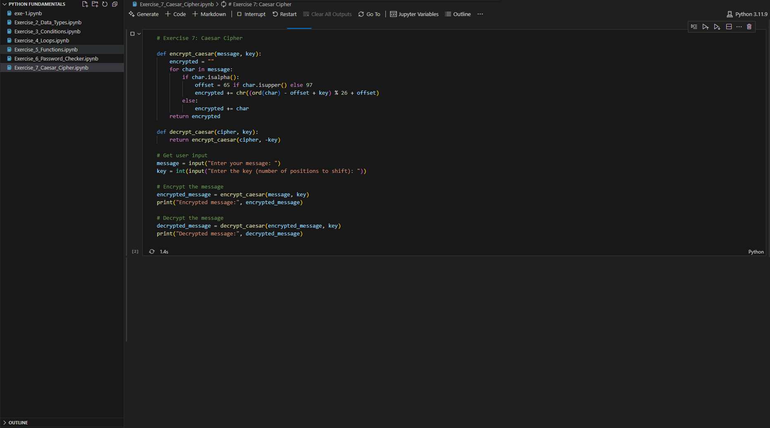  
  
  
Exercise 8



